
China crossword puzzle
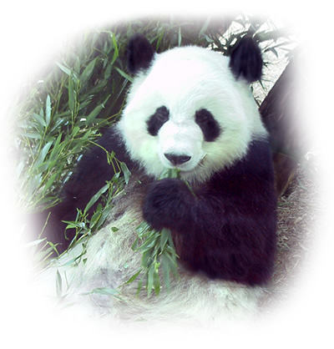

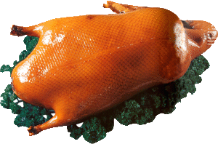
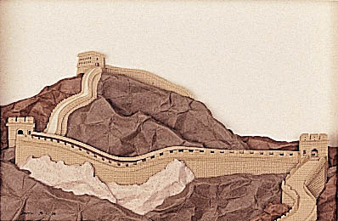

Across
2. What is the capital of China?
4. What sport is Liu Xiang , Chinese Olympic champion famous for?
5. What is a famous Chinese food from Beijing?
7. How many __________ are in the Chinese national flag?
8. What endangered animal lives in the mountains of China’s Sichuan province?
9. Yao Ming is a famous Chinese ______________ in the NBA.
11. Hainan ___________ is a tropical island of China.
12. Guilin is famous for its ___________ mountains and rivers.

Down
1. What is the economic capital of China?
2. ___________ and ping pong are popular Chinese sports.
3. The Beijing _______ ______ and the Summer Palace are historic Chinese constructions.
6. The terracotta _____________ are a great archaeological discovery in China.
10. What do pandas eat?

Answers for teachers

Across
2. Beijing
4. hurdles
5. Beijing duck
7.stars
8. panda
9. basketball player
11. island
12. caves

Down
1. Shanghai
2.badminton
3. Great Wall
6. warriors
10. bamboo

