Indiana Jones and the Temple of Doom
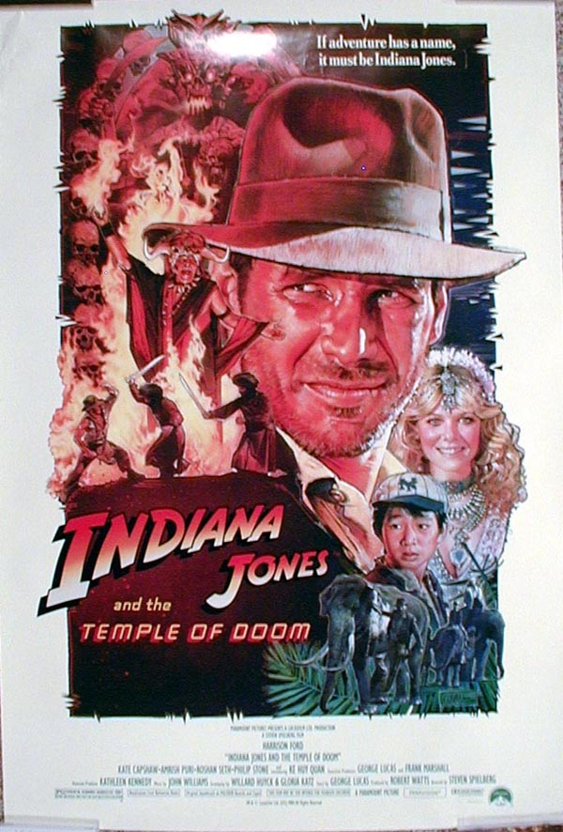

Levels:
Pre-intermediate & intermediate
Vocabulary:

Poison drink, antidote, diamond, take someone hostage, archaeologist, raft, plane crash, pilot, waiter, car chase, escape, parachute, fuel, run out of fuel, gang leader, abandon, shooting, pick up, jump out, get on, run out, fly away, drive off, dangerous, exciting, adventurous, Dr. Jones

Group the vocabulary above under the right heading

Nouns | Verbs | occupation | adjectives
diamond | escape | pilot | beautiful
Grammar Focus:
Simple past tenses, phrasal verbs (pick up, jump out, get on, run out, fly away, drive off)

Questions and Answers
- What did the gang leader want from Dr. Jones?
- What is Dr. Jones’ occupation?
a) Doctor b) Pilot c.) Archaeologist
- How did Dr. Jones get the diamond from the gang leader? What did he do with the woman?
- How did the gang leader get the diamond from Dr. Jones?
- What was in the drink that the gang leader gave Dr. Jones?
- What did Dr. Jones need to overcome the effect of the poison?
- Why was it difficult for Dr. Jones and the woman to find the antidote?
- How did Dr. Jones escape from the shooting?
- Who picked them up in the streets?
- How does the little boy feel about driving?
- Did the people succeed to catch Dr. Jones during the car chase?
- Why do you think the gang leader was laughing when Dr. Jones got on the plane? ( teacher should pause and ask students to predict what happens next)
- What did the pilots of the plane do?

- What was Dr. Jones doing at this time?
- Could Dr. Jones fly the plane?
- What did he notice when he tried to fly the plane?
- How did they get out of the plane? What did they use?
- How can you describe the jump?
- What happened to the plane?
- What country did they end up in?
- What do you think is going to happen to them next?
(The best guess wins a price)

Story retelling

Describe the movie you have just watched in twelve sentences to the class.

1.
5.
6.
2.
3.
4.
12.
7.
8.
9.
10.
11.

