TV show crosswords
Word Bank
Because
Funny
Interesting
Amazing
Exciting
Cartoon
Boring
Comedy

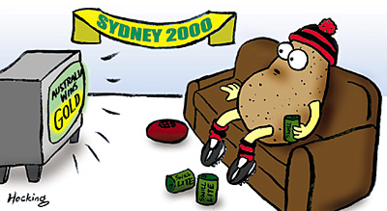
Across
2. Mr. Bean is a funny British____________.
6. Nature programs are_____________.
8. News Programs are_______________.
Down
1. Magic shows are____________.
3. Tom and Jerry is a___________.
4. Comedy shows are __________.
5. I like sports programs__________ they are interesting and exciting.
7. Sports shows are____________.

Copyright© 2005 Kisito www.esl-galaxy.com

