Free
Free
Title
Cue word here
Cue word here
Cue word here
Cue word here
Cue word here
Cue word here
Cue word here
Cue word here
Key word

Key word

Key word

Key word

Key word

Key word

Key word

Key word

Key word

Key word
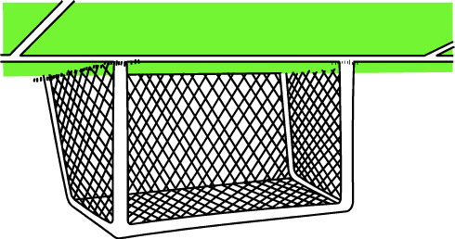
Key word

Cue words here

Cue words here

Cue words here
Cue words here
Key word

Copyright© 2006 Futonge Kisito www.esl-galaxy.com & http://www.english-4kids.com/
Talking Football

Skills to practice:
Practice almost any grammar, vocabulary and sentence structures skill with this game communicatively.
Class Levels: Adaptable for all levels of students and all class sizes.
Requirements: Cut out the game resources below. Cut out the balls or players and use as markers
How to play:
- Prepare a list of key words you want to practice. For example if you want to practice making sentences using the simple past tense, choose a number of verbs you want to use as key words.(For example, read, eat, go, dance, visit etc.) Type in the key words to fill in the spaces. Students are expected to combine these verbs with the Cue words to make correct sentences. For a class of dummies, give them the verbs in the simple past form. For smart classes give them the words in the infinitive form. That way they will first figure out what the simple past is and then combine with the cue words to make sentences.
- Choose some CUE WORDS that students can use to combine with the KEY WORDS to make full sentences. Write the cue words on the cue words section. For example if this game was about simple past tenses, the cue words could be Yesterday, last night, last month, last weekend, last summer, two days ago
- The two teams or players would toss a coin to decide who starts first, or do Rocks, Paper and Scissors. The winner starts combining a cue word and a key word to make sentences. For example Last summer + visit
Last summer I visited my grandma.
- The other team or player must listen carefully to spot the mistakes. If there isn’t any mistake in the sentence, the player can keep his/her space.
- If there is a mistake the team or player gets a yellow card and move back one step. If no mistake they keep their captured space. The other team takes its turn to combine cue words and keys words to make sentences. Every successful sentence means they retain the space and prepare to advance.
- Both teams (players) keep advancing until they meet on one space. When they meet they do ROCKS, PAPER and SCISSORS. The team that looses the ROCKS, PAPER & SCISSORS guess, gets a red card and goes back to start. The winning side continues until they meet again. Every time they, meet they do rocks, paper, and scissors to see who gets a red card. The team that gets to the other team’s goal, wins.
- When players get to the centre, it is a FREE space so they can create any sentence they like.
- If you decide to continue, try different key words or swap sides after the first side wins.
- Feel free to adapt this game for your classes as you like. Also feel free to modify or add rules.
Tips for large classes:
This game is a board game, but can also be played in a large class. Photocopy the game on an A3 or larger paper size, or project in on a projector if your class has one. Use blue tag to stick team players as they advanced.

Copyright© 2006 Futonge Kisito www.esl-galaxy.com & http://www.english-4kids.com/

Football Game equipment

Player A

Player B

Copyright© 2006 Futonge Kisito www.esl-galaxy.com & http://www.english-4kids.com/

Cards

Copyright© 2006 Futonge Kisito www.esl-galaxy.com & http://www.english-4kids.com/

Trophy

Copyright© 2006 Futonge Kisito www.esl-galaxy.com & http://www.english-4kids.com/

Football game set up for large classes can look like this.

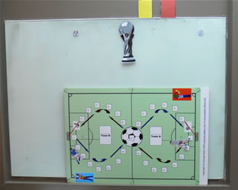

Copyright© 2006 Futonge Kisito www.esl-galaxy.com & http://www.english-4kids.com/

